A Multi-Agent FLISR Model for Safety-Critical Smart Grids

**Chaudhry Talha Hassan, Muhammad Shamaas, Tariq Mahmood Jadoon**

Department of Electrical Engineering, Lahore University of Management Sciences, Lahore 54792, Pakistan

chaudhry.hassan@lums.edu.pk, muhammad.shamaas@lums.edu.pk, jadoon@lums.edu.pk

**Abstract** –*After a major blackout, a self-sufficient smart grid can restore healthy nodes by forming microgrids around black start distributed generators (DGs). These microgrids grow gradually over time until all the critical loads are restored. The constellation of faults and radiality constraints determine the load pick-up order and boundaries of microgrids. However, the microgrid restoration optimization model can only approximate the steady-state power network equations. The implementation of the optimal solution may be infeasible if the unpredictable transient response triggers the electrical protection system. Hence, the transient results of electrical power flow must be used to enforce dynamic stability after every restoration stage. In this research, measurements from distributed phasor measurement units (PMUs) are used to quantify the disturbance experienced by the loads, generators, and lines. This feedback is used to restrain the restoration algorithm so that the microgrid gets sufficient time to stabilize.* *Decentralized control is implemented to solve the serious challenges of* *information discovery, real-time task scheduling, communication network congestion, and big data analysis. The importance of multi-agent coordination for power system dynamic stability is analyzed by simulating network congestion of control and metering systems. The approach is validated over a modified IEEE-123 node test feeder, and the results are presented to demonstrate the efficacy of the framework for multiple fault scenarios.*

**Keywords:**Wide-area situational awareness (WASA), mixed-integer second-order cone programming (MISOCP), inverter-based distributed generator (IBDG), energy storage system (ESS)

# Nomenclature

Sets

Set of bus blocks.

Set of generators with black start capability.

Set of generators.

Set of inverter-based generators.

Set of distribution lines.

Set of generators without black start capability.

Set of non-switchable lines.

Set of phases.

Set of synchronous generators.

Set of switchable lines.

Set of loads.

Indices

Index of bus block.

Index of generator.

Index of bus.

Index of distribution line.

Index of microgrid.

Index of phase.

Index of time step.

Index of load.

Parameters

Multiplier for dynamic stability factor equation.

Imaginary part of transmission line admittance.

Load damping rate

P-⍵ and Q-V droop gains.

Nominal steady state frequency.

Maximum allowable frequency limit.

Minimum allowable frequency limit.

Real part of transmission line admittance.

System inertia.

Maximum phase current limit of distribution line .

Power factor angle of constant current load.

⨉ matrix of ones.

Big-M number.

3⨉3 phase matrix of line .

Maximum output real power limit of generator .

Maximum output real power limit of distribution line .

Power factor angle of constant power load.

Line loss factor for active power.

Maximum output reactive power limit of generator .

Maximum output reactive power limit of distribution line .

Line loss factor for reactive power.

3⨉3 resistance matrix of line .

Maximum output apparent power limit of distribution line .

Maximum input apparent power limit of ESS .

Maximum output apparent power limit of generator .

Nominal apparent power rating of ZIP load.

Maximum limit of SOC for ESS .

Minimum limit of SOC for ESS .

Length of rolling horizon.

Maximum squared voltage magnitude limit of bus .

Minimum squared voltage magnitude limit of bus .

Nominal phase to ground rms bus voltage.

Priority weight for load of bus .

3⨉3 Reactance matrix of line .

3⨉3 Impedance matrix of line .

Power factor angle of constant impedance load.

Limit for maximum allowable frequency deviation.

Measured maximum transient frequency deviation.

Limit for maximum allowable current deviation.

Measured maximum transient current deviation.

Limit for maximum allowable voltage deviation.

Measured maximum transient voltage deviation.

Time step between two restoration stages.

Charging efficiency of ESS .

Variables

Disturbance factor of microgrid at stage .

Real power injection at bus .

Active power output of ESS , phase at stage .

Limit of maximum restored load for microgrid at stage .

Active power flow of line , phase at stage .

Active power loss of line , phase at stage .

Active power output of generator , phase at stage .

Active power demand of load , phase at stage .

Reactive power injection at bus .

Reactive power output of ESS , phase at stage .

Reactive power flow of line , phase at stage .

Reactive power loss of line , phase at stage .

Reactive power output of generator , phase at stage .

Reactive power demand of load , phase at stage .

SOC of ESS , phase at stage .

3⨉1 squared three-phase voltage magnitude matrix of bus at stage .

Phase to ground rms voltage of bus at stage .

Binary energization status of bus .

Binary energization status of bus block .

Binary charging status of ESS .

Binary energization status of generator .

Binary energization status of line .

Binary energization status of load .

Increased output from inverter-based generators.

Total generation loss.

Maximum limit for restored load of microgrid at stage .

Increased output from synchronous generators.

Angle of voltage at bus .

# Introduction

Advancement in smart grid technologies has called for higher reliability of service to consumers. Although faults and outages are inevitable, service must be restored to normal in the event of a blackout. During such an emergency, the generation capacity and energy reserves must be carefully utilized to recover critical loads. An effective method for emergency service restoration is the sectionalization of the power network into microgrids [1]. These autonomous units coordinate all the decisions for self-healing. Hence, power restoration can be achieved in a distributed and decentralized manner [2].

Bulk power distribution networks have limited number of switchable lines and loads [3]. Hence, the network can often be sectioned into large bus blocks [4]. Switching many inductive loads at once can result in severe frequency and voltage oscillations. This makes the service restoration process very hasty and aggressive. Voltage and current spikes can get amplified when they pass through distribution transformers. Such hostility can cause severe damage to inverters and energy storage devices [5].

Modern smart grids can have an extensive range of loads, switches, and auxiliary equipment. Multiple practical limits must be considered for the sequential switching of manual and remote-controlled switches [4]. The operating time of a switch can be impacted by its type, its location [6], and the constraints of the communication channel [7]. Coordination of switches is also important to prevent the overloading of power generators. All the possible changes in network topology must be considered to make feasible microgrids with radial structure and sufficient generation capacity [7].

Microgrid restoration can be very challenging for inverter-dominated smart grids because these networks suffer from poor dynamic stability [8]. Operating multiple inverter-based generators can be difficult if they have dissimilar droop characteristics and ramp limitations. The unpredictable nature of non-linear semiconductor devices makes inverters especially susceptible to damage during electrical overloads, voltage fluctuations, and short-circuit faults [9]. Inverters can face commutation failure or permanent damage if the maximum limits for safe operation are breached [10]. Optimal power exchange must be ensured to prevent the overstressing of IBDGs [2].

The most serious problem with restoring three-phase unbalanced power distribution networks is the overheating of generators due to current unbalance, excessive ramping, frequency drop, and voltage oscillations [11] [12]. To prevent damage to generators, a sufficient spinning reserve must be maintained to compensate for errors in load forecast [1]. The microgrid frequency response rate can be approximated based on the total generation capacity of restored generators [14] [15]. By limiting the ramp rate of synchronous generators, the RoCoF can be reduced to a reasonable value [13] [10] [16]. The health of energy storage systems must also be monitored for inverter-based generators. A strategic charging and discharging strategy must be formulated to maintain SOC within a safe limit [13]. Such approximation methods can effectively constrain the maximum frequency drop by limiting the maximum recovered load in each stage [12]. However, these techniques cannot be applied to inverter-based generators with unbalanced loading [9] [8]. The frequency response of low-inertia inverters is highly unpredictable. Static as well as dynamic constraints for voltage, current, and frequency must be imposed to prevent damage to sensitive electronic equipment [17] [18] [8] [3] [5].

Power flow analysis is a useful tool for a variety of power system applications. Several models and algorithms have been developed for optimal power flow analysis. This convex problem can be simplified through several approximations and relaxations. Constant current and constant impedance loads can be represented using linearized power flow models [11]. Shunt capacitors, voltage regulators, and distribution transformers can also be represented using linear constraints. Overloading of transformers and transmission lines can be prevented using quadratic or approximate polygon-based linearized constraints [13] [11]. The problem of power flow in an unbalanced multi-phase radial network has been solved using semi-definite programming. Conic and semi-definite optimization is useful for transmission system planning and distribution system reconfiguration. Mixed-integer models with quadratic, conic, and semi-definite optimization have been successful for power loss analysis [15]. Load flow problems in radially distributed networks have been solved by convex or conic optimization programs [15]. Although complex optimization problems can accurately model the steady-state behavior of these power system elements, their transient behavior cannot be predicted. An active wide-area monitoring system is required to ensure safe operation during switching operations and power shuffling [3].

A centralized approach to load restoration considers it as a classical optimization problem to maximize critical load pickup while incorporating power system constraints. The restoration process can be optimized through various techniques. The most powerful methods for solving this optimization problem include mixed-integer linear programming, dynamic programming, multi-agent systems, and heuristic algorithms [19]. Although it can lead to suboptimal solutions, linear programming has the lowest computation cost and the highest rate of convergence compared to all other methods [4]. For fault restoration of smart grids involving renewable energy sources, energy generation cannot be accurately forecasted [19] [15] [2]. Load diversity can also be highly unpredictable after a blackout [13] [7]. Hence, a combination of stochastic optimization and mixed-integer linear programming is preferred. This can provide reliable solutions with a high convergence rate and computation speed [13] [19] [18] [2] [20].

The role of a synchronous generator as a black-start capable DG has not been studied in detail for service restoration problems. Besides improving electrical stability, high-inertia diesel generators can act as reliable power sources, unlike renewable energy generators [21]. There are new opportunities to consider synchronous generators or backup generators (BUGs) as a source of black start capability [10]. Ramp constraints, inertial capacities of prime-movers, and generator excitation characteristics are important for modelling their operation. By incorporating these constraints, the utility of BUGs can be increased to harness power and improve microgrid stability.

Standardization of smart grid communication technologies has offered new opportunities for improving protection and control of green smart grids. With the increasing installation of remote-controlled smart switches, tie-lines, isolators, and distributed energy resources, there is a growing need for improving this communication layer in cyber-physical distribution systems. Power quality monitoring modules integrated with high-frequency transceivers allow real-time monitoring of transient fault records with millisecond precision. Active management of smart grids is now possible with improved processing power and fast networking solutions.

# Motivation And Contribution

Reconfiguration of an inverter-dominated distribution system is a complex combinatorial problem due to non-linear power flow equations and the unpredictable generation of renewable energy sources. A highly complicated optimization scheme is needed to incorporate all the intricacies of the analog and digital components. The optimization model can only approximate the electrical power network equations. Hence, the results of electrical power flow must be used to reinforce dynamic stability after every restoration stage.

An intelligent control system must be well informed about the situation of all the constituent subsystems. The control commands must be based on real-time data obtained from distributed field devices. In short, an active management system is needed to sense and optimally control all the distributed subsystems. The proposed FLISR model is shown in Figure 1.

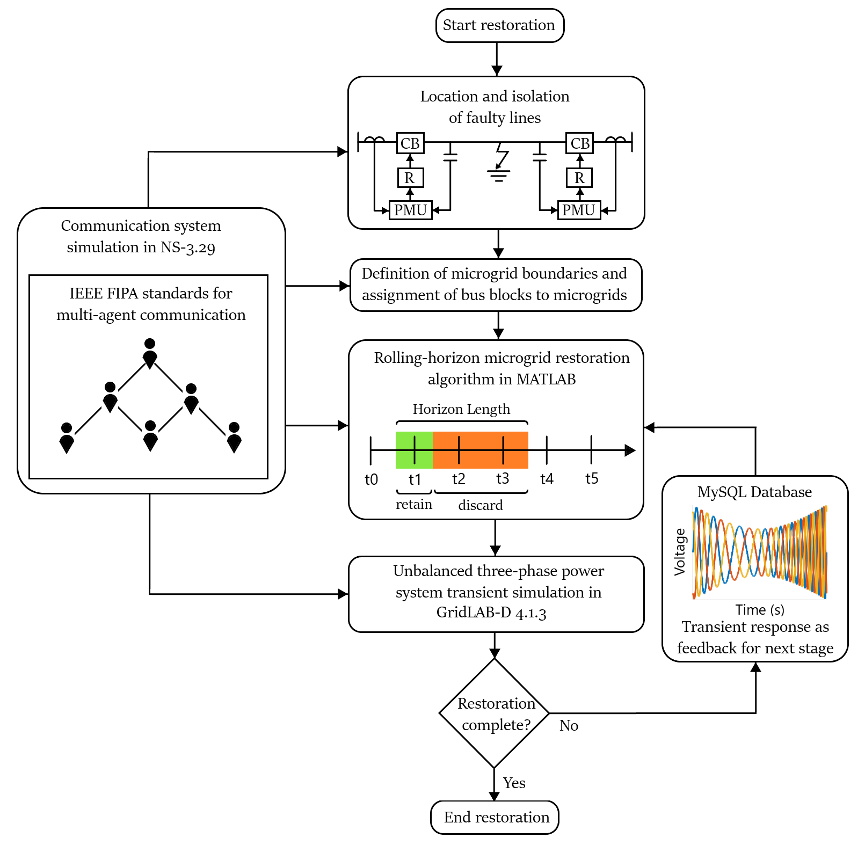

Figure 1: FLISR model.

The restoration optimization problem is formulated as a mixed-integer second-order cone program. The restoration commands were implemented over a distributed control framework. All the loads, generators, and switches could be controlled remotely. The different subsystems used two-way negotiations to exchange information and control signals across the network.

In this decentralized restoration scheme, microgrid agent solved the restoration rolling horizon optimization problem using the MISOCP algorithm. Bus block agents located and isolated the fault based on the locally available information, and assisted the microgrid agent in reconfiguration and restoration. Switches were used to connect bus blocks together.

Based on the communication requirements, network traffic was simulated in NS-3 to determine the latencies and QoS parameters of the network. The resulting reconfiguration commands and inter-switch operating delays were finally simulated in GridLAB-D to determine the transient response.

This work makes an important contribution to the cyber-physical implementation of a resilient distribution system. For effective sequential microgrid restoration, the effects of past decisions must impact the formulation of the next optimization stage. After each restoration stage, a scan of the entire network was acquired to judge the electrical stability of the recovered region. Further load restoration was delayed if the network qualified as unstable. The real-time feedback allowed the central controller to carry out time-sensitive optimization tasks. The measurements of distributed PMUs provided feedback for the next stage of the rolling horizon restoration optimization problem.

This research aims to achieve the following goals:

1. Develop a decentralized control architecture for the restoration of inverter-dominated microgrids. The utility operator was provided with all the relevant information for controlling distributed generators, reconfiguring the distribution network, and forecasting load demand. The autonomous central controller performed MISOCP optimization for all supervisory tasks. Besides routine tasks like controlling distributed generators, demand response, and Volt-Var regulation, it also performed network reconfiguration. Based on the restoration solution, it distributed control commands to the different microgrid controllers. These autonomous controllers were responsible for coordinating the operation of distributed loads, switches and generators.

2. Execute information exchange to coordinate the control and protection of microgrids during sequential service restoration. The microgrid controller was responsible for monitoring all the widespread loads, lines and generators. It aggregated the status information and distributed the control commands for all the subsystems. The hierarchical structure for data exchange was implemented using a fast and reliable communication system in NS-3.

3. Quantify the aggression afflicted during each microgrid restoration stage to provide feedback for the microgrid protection system. After every restoration stage, the transient fault records of the GridLAB-D simulation were analyzed to quantify the disturbance experienced by the microgrid. The maximum deviations in load voltages, line currents, and generator frequencies were used to calculate the microgrid disturbance factor. A rolling horizon optimization framework was implemented to modulate the load restoration limit based on the microgrid disturbance factor. This factor restrained the sequential restoration algorithm so that the next stage could be improved.

# Formulation Of Optimization Problem

A MISOCP optimization problem was formulated for the restoration of the damaged IEEE-123 bus system shown in Figure 2. The modified network contained three-phase diesel generators, PV generators, and EV charging stations. Each generator had a rating of 1 MVA and a ramp limit of 150 kW/s.

The service restoration system executed a self-healing algorithm. The initial decision for network reconfiguration was based on the fault location input. The unhealthy region was isolated immediately. Afterward, iterative microgrid formation started.

The healthy bus blocks were enumerated and grouped based on geographic proximity. The bus blocks that could be connected via switchable lines were assigned a microgrid. This determined the boundaries of the microgrids.

For each microgrid, a root node was assigned, which would be solely responsible for solving the microgrid restoration problem. The high-rank node had a diesel generator with black start capability. An iterative depth-first search algorithm was used to rank bus blocks in order of energization. The bus blocks closer to the root node would be energized earlier.

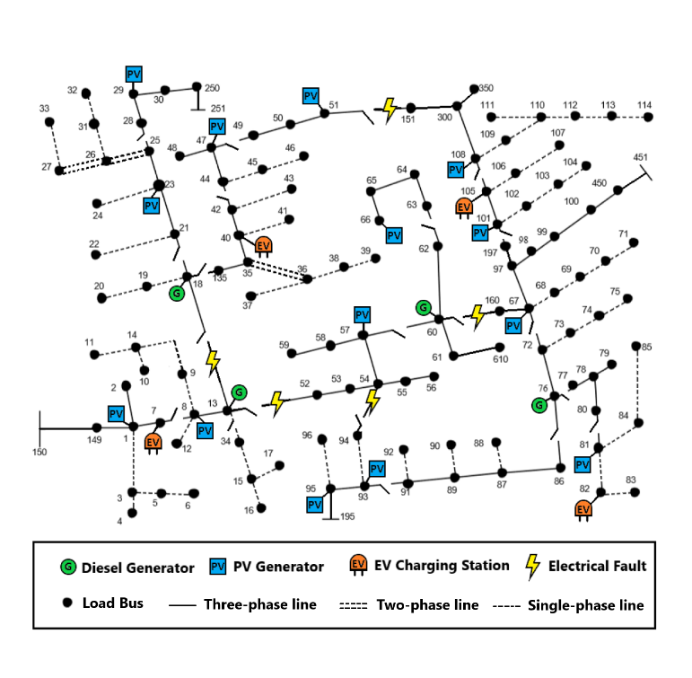

Figure 2: Damaged IEEE 123 bus distribution network

Operational planning determined the optimal switching pattern for demand response management, network reconfiguration, fault level management, and Volt-Var control. Load forecast, unit availability, and energy storage capacity were used for controlling generation.

The objective function (1) aims to maximize the total recovered loads over a rolling horizon . The priorities of the bus blocks were assigned randomly. Each load had the same weight as its bus block.

1. Nodal power balance constraints: Constraints (2)-(3) define the nodal balance of active and reactive power for each phase. The linearized DistFlow equations were used to approximate the electrical power flow [2]. They state that the generated power must be equal to the sum of load demand, transmitted power, and line losses.

2. Transmission line constraints: Constraints (4)-(7) define the limits for transmission line active power losses and reactive power losses. The line losses were calculated using the average loss factor and the apparent power flow of the line. The line loss factor was estimated by assuming a maximum voltage drop of 5% across the line.

Constraint (8) defines the transmission line’s active and reactive power flow limits. Constraints (9)-(10) state the conditions for the energization of switchable lines. Constraint (11) implies that non-switchable lines are automatically energized whenever the corresponding bus is energized.

3. Generation constraints: Constraints (12)-(13) define the active and reactive power generation limits for generators. Constraints (14)-(18) define the operational limits for charging and discharging of energy storage systems. Constraints (19)–(20) state that a generator without black start capability can only be started if its associated bus is energized, and it cannot be turned off afterwards. Constraints (21)-(22) define the output active and reactive power ramp rates for the distributed generators (PV inverters, PHEV inverters, and diesel generators).

4. Load constraints: Constraint (23) states that a load is energized whenever its corresponding bus has been energized. Constraint (24) states that once a load has started operation, it cannot be stopped.

5. Nodal voltage constraints: Constraints (25)-(26) define the limits for the voltage difference between the end nodes of a transmission line. The Big-M notation is used to ensure that these constraints are active only when the line is energized. Constraint (27) ensures that the bus voltage is constrained within predefined limits.

6. Bus block switching: The healthy bus blocks were enumerated and grouped based on geographic proximity. The reduced network contained a set of bus blocks that were connected by a set of switchable lines:

The reduced IEEE-123 bus system is shown in Figure 3. Constraint (29) ensures that all the buses in a bus block get energized simultaneously. Constraint (30) ensures that a switchable line cannot be closed if both of its end blocks are already energized. This is required to maintain radial tree topology during microgrid restoration. Constraint (31) states that a bus block can only be switched on by one of the connected switchable lines. Constraint (32) makes sure that at least one connected switchable line is energized before the energization of the bus block. Finally, constraint (33) implies that a switchable line can be energized only if at least one of the connected bus blocks is already energized.

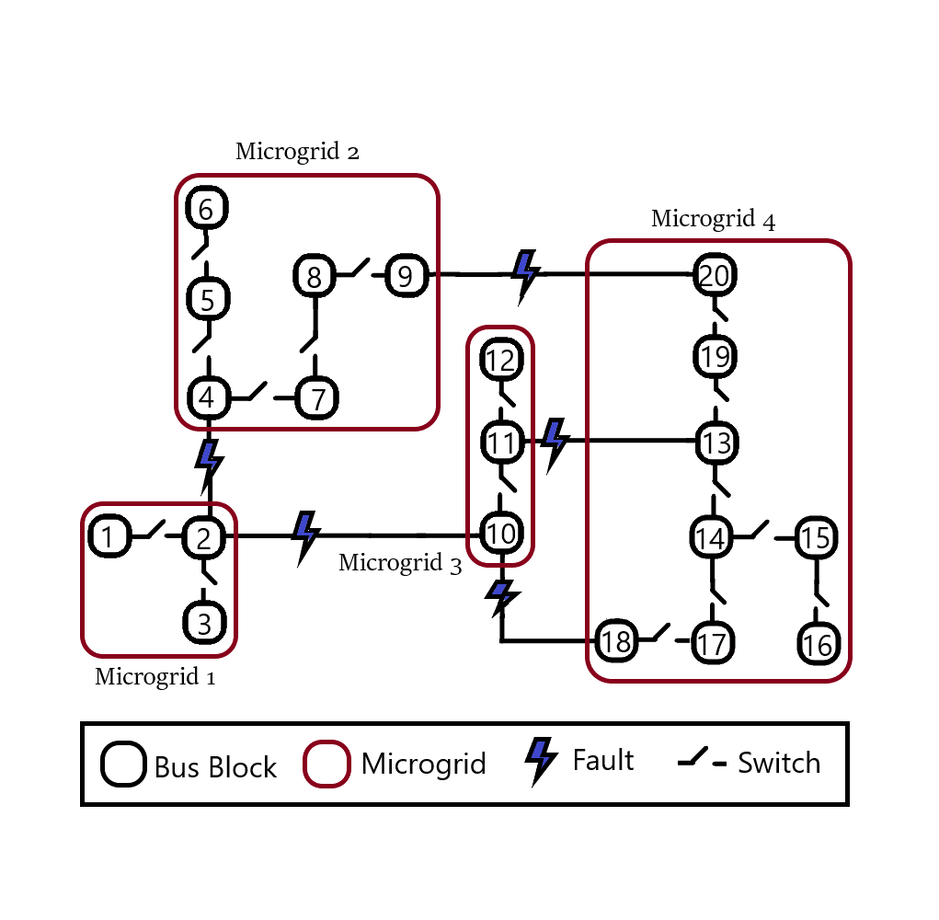

Figure 3: Reduced IEEE-123 bus power network showing bus blocks and microgrids.

7. Dynamic constraints: After a restoration stage was executed, the maximum values for nodal frequency deviation, nodal voltage deviation, and line current deviation were recorded. These values were translated into a numerical parameter for expressing the state of the microgrid. Equation (34) presents the formula for calculating this microgrid disturbance factor. This factor was used to restrain the amount of restored load in the next stage, as expressed in (35)-(36). The maximum nodal voltage deviation and line current deviation of each phase was incorporated to discourage unbalanced loading of the lines and generators.

# Multi-agent Coordination Model

The implementation of the optimal solution can present serious challenges during information discovery, real-time task scheduling, communication network congestion and big data analysis. Perfect coordination must be maintained between the microgrid controller, distributed generators and smart switches to prevent microgrid instability.

The distributed control system has to schedule multiple hard real time tasks for execution of the optimal solution. It must also ensure that each real time task has reasonable delay, duration and deadline constraints. Centralized control is not a viable option for this safety-critical system. The geographically distributed events must be handled locally to prevent overloading of the communication system.

A multi-agent control scheme was developed to facilitate information discovery, real-time task scheduling, communication network load balancing and big data analysis. The complete multi-agent system for a microgrid team is shown in Figure 4. Each microgrid was divided into several bus block teams headed by bus block master agents. Switch agents were responsible for connecting bus blocks together. Switch agents and bus block agents were controlled by the microgrid controller. Bus block agents were responsible for distributing control commands to the slave agents in their team. Master agents also collected status signals and sent them to the microgrid controller.

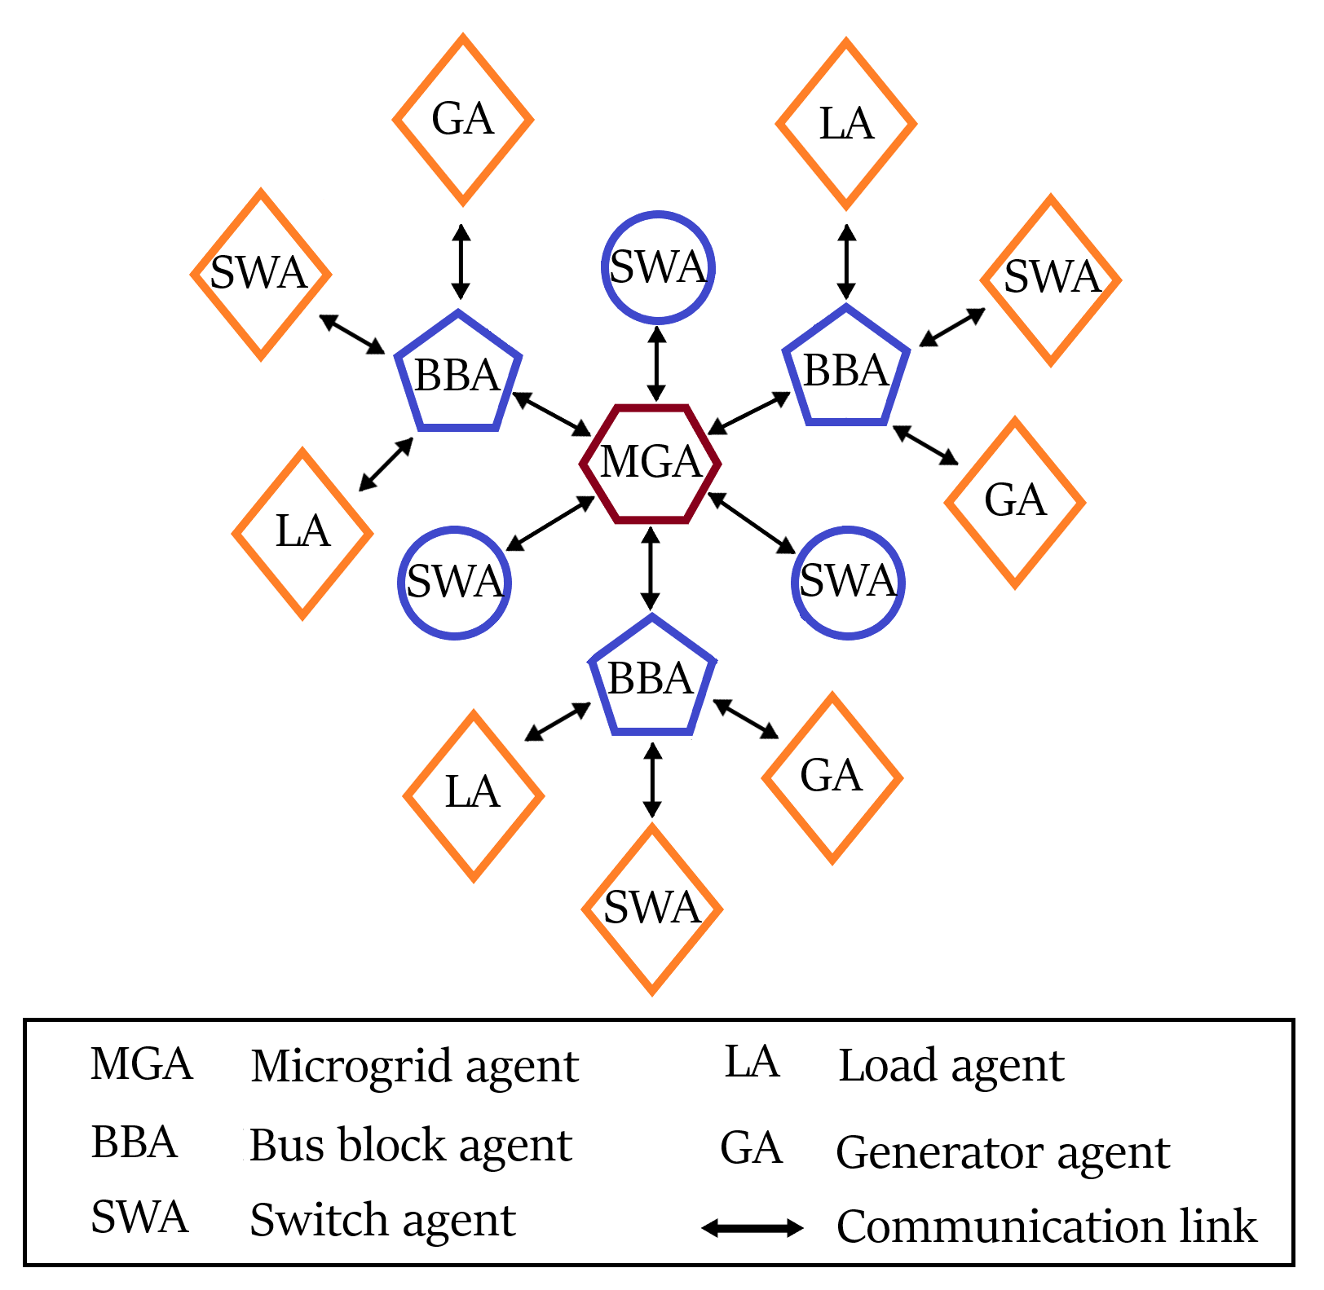

Figure 4: Multi-agent system for a microgrid.

Agents have the ability to communicate with other agents based on local information. Different groups can cooperate to restore the power system. The MAS structure is not fixed, but changeable according to complexity of faults. The system kept a minimal number of agents during normal operations when no fault was detected. However, when faults were detected in the system, a reasonable number of agents were generated to restore the system. When the faults were cleared, the extra agents were destroyed. The system provided reasonable solutions for faults at different complexity levels. Microgrid groups were generated to provide the local optimized solution.

Each agent had an embedded computer system to collect PMU data from the environment, process the collected information and control actuators. Immediate failure detection is very important for safety-critical systems. A feedback system was responsible for detecting faults and improving the performance of the control system. The behaviors of master and slave agents are shown in Figure 5. Depending on the role of the agent, the communication system was used to exchange status and control signals with the master and slave agents.

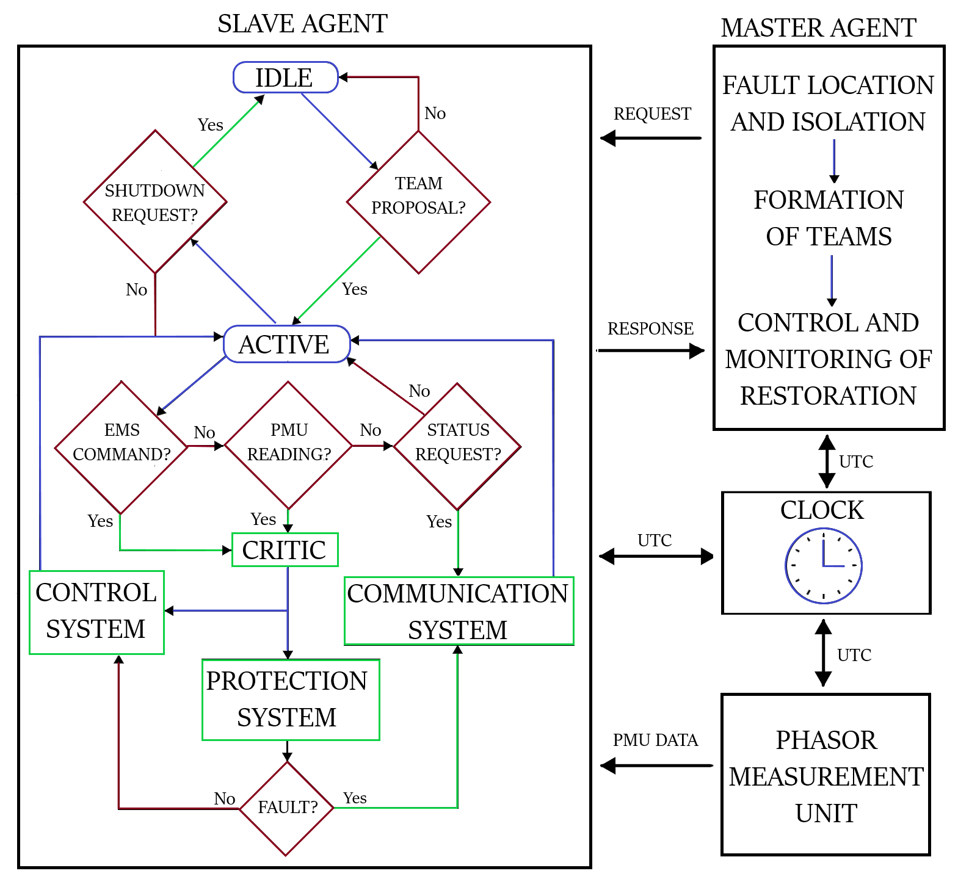

Figure 5: Behaviors of master and slave agents.

To ensure dynamic stability, a large volume of field data was collected, transmitted, aggregated and processed at the microgrid control center. The PMU data collected using bus block SCADA system was concentrated before transmission to the microgrid controller. Concurrent database access was valuable for aggregating real time data received from multiple bus block teams.

These teams consisted of intelligent agents with the ability to interpret data and run autonomous actions to change the environment state. The agents were characterized and differentiated by their defined behaviors. A common ontology was used for the purpose of enabling knowledge sharing and reuse by the community of agents. Hence, they exhibited characteristics of autonomy, reactivity, proactivity and sociability.

IEEE FIPA standard was used to build a unified model for the communication of reactive agents. Agent Communication Language (ACL) was used to transmit information signals between agents. A simple example of a microgrid with two bus blocks is shown in Figure 6. The stimulus event for unexpected generator fault was simulated to trigger the multi-agent system response. Different agent behaviors were defined to ensure that the desired communication sequence was generated. The unhealthy bus block was isolated by requesting the switch agent to open the connecting switch.

After the isolation of the fault, the microgrid agent sent team proposals to the bus block and switch agents within its boundary. The agent that could join the microgrid accepted the proposal. After this handshake, the bus block agent proceeded to build its own team of load and generator agents.

The microgrid agent solved the MISOCP optimization problem and sent the control commands to the bus block team leader. The bus block agent made sure that all the bus block team members were informed about the upcoming switching action. Load and generator agents informed the bus block agent when they were ready for operation. After the confirmation, the microgrid agent commanded the switch agent to close, and the bus block got connected to the microgrid.

Afterwards, the microgrid agent inquired the bus block agent about its status. The bus block made sure that every team member was operating in a safe and reliable manner. Then, it sent the aggregated information to the microgrid agent as response.

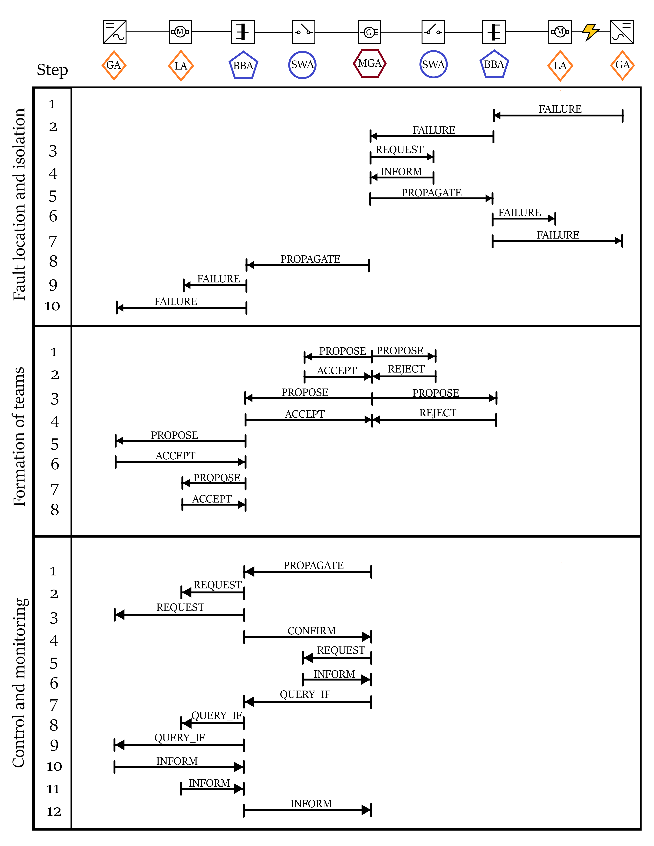

Figure 6: Multi-agent communication scheme for FLISR.

The next section shows how the latencies of communication system were calculated by simulating control and monitoring systems in NS-3.

# Communication System

A three-level communication network was designed in NS-3 to enable the coordination between the microgrid controllers and bus block controllers. Control signals were transmitted through the control system, whereas the metering data was transmitted through the monitoring system. Intelligent Electronic Devices (IEDs) installed in the field provided feedback for the reliable control of distributed generators, loads and smart switches. The complete communication system is shown in Figure 7.

1. Monitoring System

The AMI system was made up of smart meters, communication modules, data concentrators, and Meter Data Management System (MDMS). MDMS managed data storage to provide the information in a useful form to the microgrid controller. Detailed and timely meter information improved the management of utility assets. The IEEE C37.118 synchronized phasor measurement units (PMUs) reported the magnitude and phase angle of electrical voltage and current using a common time source for synchronization.

The Wide Area Network (WAN) provided remote access of bus blocks to the microgrid controller via long-range, high-capacity WiMAX links. NS-3 provided a realistic implementation of the IEEE-802.16 standard using wireless MAN-OFDM physical layer, uplink and downlink schedulers, IP packet classifier for the convergence sub-layer, and support for multicast traffic [24]. A base station was installed to serve the subscriber stations installed at the microgrid controller and the bus block controller nodes. The point-to-multipoint telecommunication network enabled pervasive control of the entire distribution system for time-sensitive tasks like maintaining electrical stability.

Existing power lines were used to transmit control and status signals across the Field Area Network (FAN). 2 Mbps links were used for power line carrier communication. Each power line communication device was supplemented with a data concentrator for communication with the widespread IEDs. Distributed generators were controlled via programmable logic controllers integrated with SCADA modems. The transmission line channels also conveyed switching commands for capacitor banks, load controllers, and circuit breakers. To ensure dynamic stability throughout the restoration, status signals from all the bus blocks were relayed periodically to the microgrid controller.

The Home Area Network (HAN) connected load controllers and sensors via an Ethernet-based AMI. This enabled coordination of a large number of distributed IEDs. These devices continuously collected information from power meters, transducers, and field components for supervision. 100 Mbps Ethernet links were installed for the Home Area Network. For fast and reliable communication, the IPv4 protocol was implemented in the network layer, and the UDP protocol was implemented in the transport layer. The IEDs were complemented with data concentrators for integration; and remote terminal units for communication channel interfacing. The network interface module implemented distributed network protocols for physical interface conversion. The pervasive communication system enabled continuous scanning of operational data for greater control and flexibility.

1. Control System

The microgrid controller distributed command signals using high priority control packets. It was crucial to transmit control signals reliably with very low latency. Control signal channels were designed to have low bandwidth but very high reliability (> 99 %). The maximum constraint for control packet latency was 20 ms.

The priority associated with a socket was used to determine the value of the Differentiated Services field (RFC 2474) of the IPv4 header. This is how DSCP values mapped onto priority values of the packets sent through that socket. DSCP CS6 (RFC 4594) was assigned for high priority network control packets. The packet priority was used by queueing disciplines to classify packets into distinct FIFO queues.

The microgrid agent was connected to the bus block agents using wireless LTE links in NS-3. The microgrid controller was connected to bus block UE through eNB, SGW and PGW nodes. The 3GPP specified S5 protocol stack, S1-U protocol stack and LTE radio protocol stack were simulated in LTE-EPC data plane. S1-MME, S11, S5 and X2 interface was modeled for the LTE-EPC control plane.

OpenFlow switch was installed in each bus block to connect bus block agent with the generator, switch and load agents. OpenFlow switch provides the programmability and flexibility required for smart grid architectures with ever-increasing demand. It provides support for traffic engineering and virtual private networks. These features are vital to enhance the reliability and scalability of the smart grid.

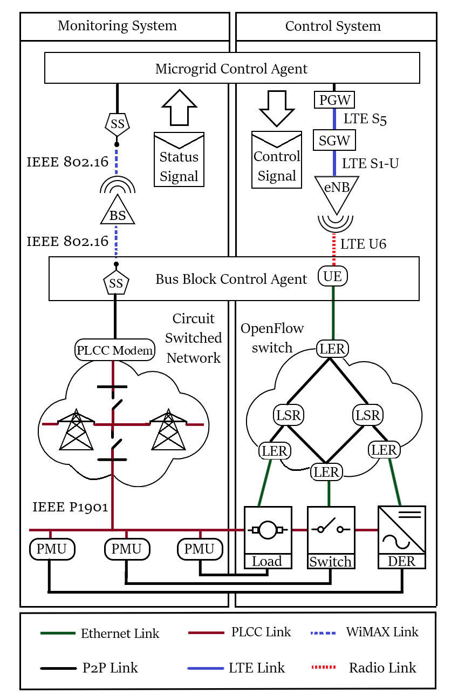

Figure 7: Communication system for monitoring and control signals.

# Power System Simulation

The IEEE 123-bus modified feeder [23] was simulated in GridLAB-D to verify the MISOCP optimization results. The simulated system was approximated by quadratic approximations in the optimization problem. As expected, the optimization problem could not predict the transient response of power system elements. The discrete-time simulation was used to monitor the dynamics of the inverter-dominated smart grid for the rolling horizon sequential power restoration.

The simulator used the Newton-Raphson method to iteratively solve the power flow equations (37)-(39) until the solution converged [22].

The optimization problem assumed all the loads to be constant power loads. However, three different types of loads were modelled in GridLAB-D: constant impedance loads, constant current loads, and constant power loads. Their power flow equations are given in (40), (41), and (42) respectively [22].

The transmission lines were simulated using actual parameters for the IEEE-123 bus model. The lumped parameter pi-line model (43) was used to simulate the energization of overhead lines and underground cables in GridLAB-D [22].

The optimization problem considered diesel generators as a variable PQ source without any consideration for their dynamic behavior. The GridLAB-D implementation of the diesel generator is shown in Figure 8. It incorporated the dynamic behavior of the electromechanical control system for a realistic implementation of a synchronous generator [22].

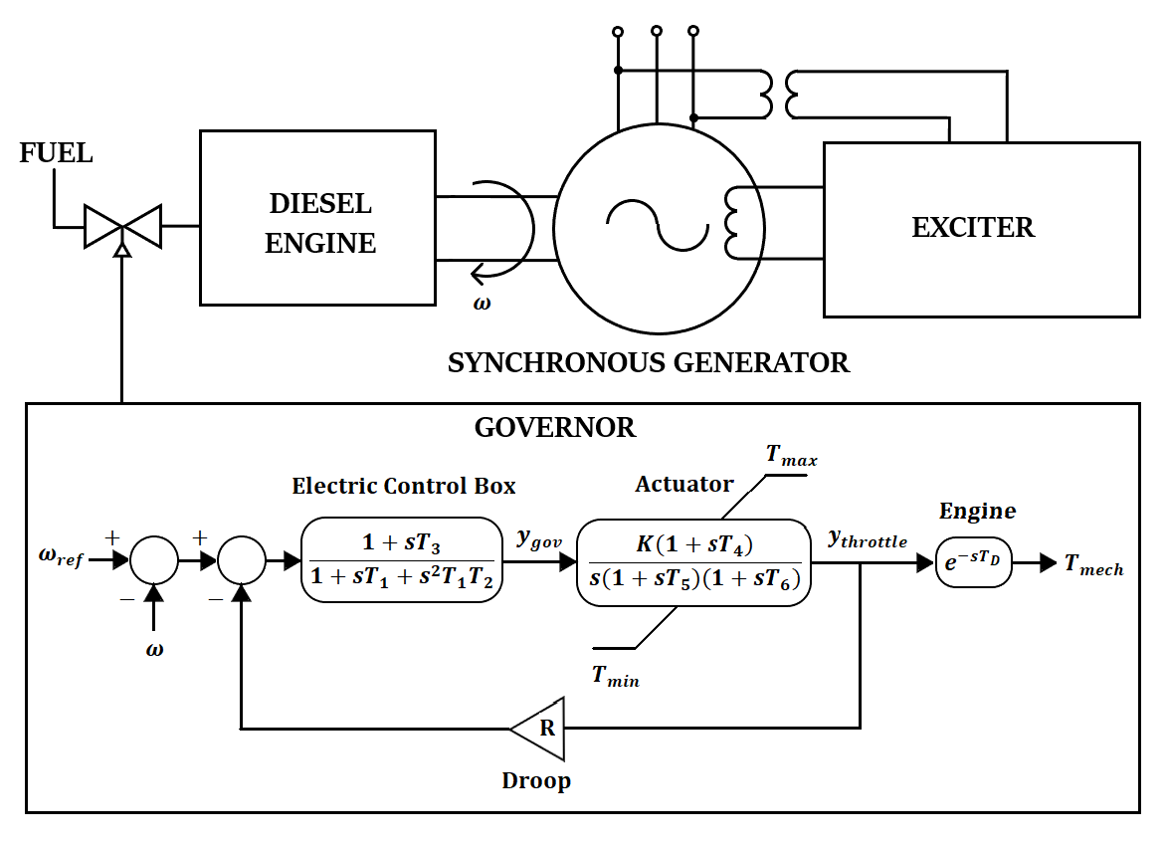

Figure 8: Diagram of diesel generator.

Similarly, the optimization problem considered the inverter as a variable PQ source without considering its dynamic behavior. The GridLAB-D implementation included a more sophisticated model with frequency and voltage droop control. The diagram of the droop mode voltage source inverter [9] [22] is shown in Figure 9.

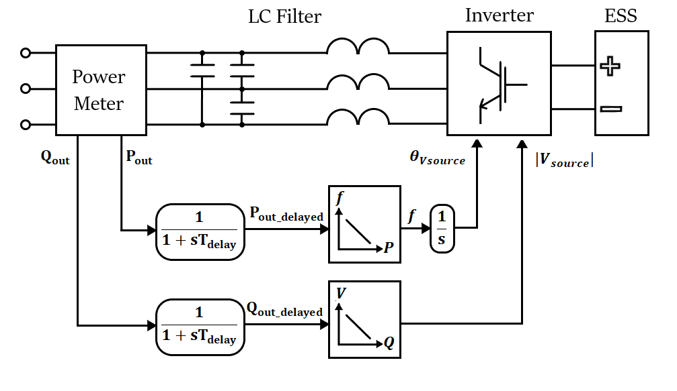

Figure 9: Diagram of droop mode voltage source inverter.

The solar panel was modeled as a controllable current source in GridLAB-D. The output current was affected by the light intensity, temperature and voltage parameters [22].

The incorporation of complex dynamic models made the simulation much more realistic compared to the optimization problem. The overall microgrid frequency response [10] can be approximated by the first-order swing equation (44).

# Simulation Results

The simulation of the cyber-physical smart grid was carried out in three steps. First, the MISOCP optimization problem was solved to determine the optimal switching and control commands. Then, the NS-3 communication system simulation was run to determine the delays in the transmission of information to different subsystems. The bandwidth and latency constraints for different applications are given in Table 1. Finally, the outputs from the previous two simulations were implemented in the GridLAB-D simulator to determine the power system transient response.

Table 1: Control and monitoring system constraints.

|  |  |  |  |
| --- | --- | --- | --- |
| Application | Bandwidth  constraint | Latency  constraint | Reliability  constraint |
| Wide-area situational awareness | 1500 kbps | 1.5 s | Medium |
| Demand and response | 100 kbps | 500 ms | Medium |
| Distributed energy resources | 50 kbps | 300 ms | High |
| Substation automation | 50 kbps | 20 ms | High |
| Distribution automation | 50 kbps | 20 ms | High |

Four microgrid teams were formed for the system. Depth-first search algorithm was used to determine ranking of energization of the bus blocks. The final results for formation of teams are shown in Figure 10.

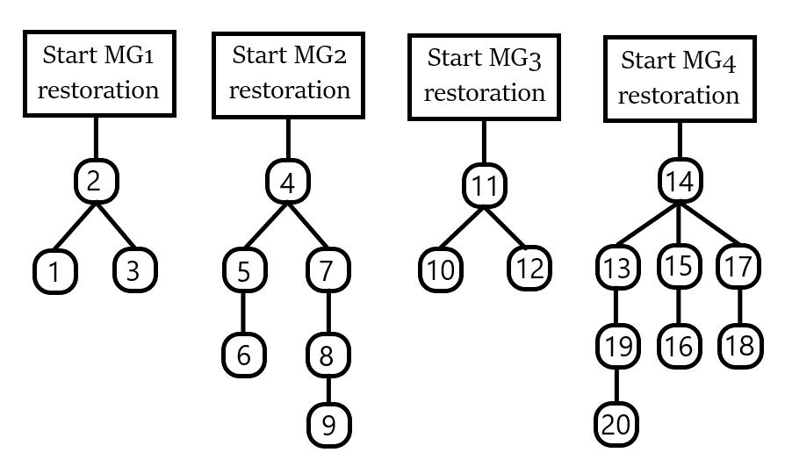

Figure 10: Energization ranking of bus blocks for four microgrids.

The optimization problem (1)-(33) was solved using GUROBI optimization software. The objective was to restore all the bus blocks in a minimum number of stages. The priorities of the bus blocks were assigned randomly.

Three different cases were studied to analyze the efficacy of the proposed dynamic feedback system in improving microgrid restoration. The first case included heavy communication network congestion, and it had the most aggressive restoration scheme. The second case included dynamic feedback to improve the restoration in case of coordination failure. The third case included perfect multi-agent coordination for the most stable restoration scheme.

Case 1: Heavy communication network congestion.

In the base case, service restoration was implemented without dynamic feedback from the power flow simulation. Heavy communication network congestion was simulated to analyze the importance of multi-agent coordination for microgrid stability.

The situation can deteriorate if the communication system fails during the service restoration. Perfect coordination is needed between the DERs, smart switches and the central controller. Before switching additional load, sufficient spinning reserve must be available in the power system. The DERs must be ramped up before switching the additional load to prevent over-stressing of the running generators. If any generator fails to start or ramp up at the correct time, the over-stressed generators can lose synchronism. This can cause huge frequency swings and trigger the electrical protection system.

Communication failure can result from unexpected data traffic, queueing delay and packet drops of the DER command signals. Another simulation was carried out to analyze the impact of communication failure on microgrid stability. As planned, grid forming generators started the load restoration. In order to simulate communication failure, the DER control commands were executed after switching the bus block loads.

The sequential load recovery sequence for each microgrid is shown in Figure 11. The load was restored in discrete steps due to the limited number of switches and ramping constraints of generators (21)-(22). This restoration sequence was very hasty as it tried to minimize the power outage time. The restoration solution was implemented in GridLAB-D power system simulator to analyze the severe effects of such an insensitive switching scheme.



Figure 11: Case 1 optimized restoration without dynamic feedback.

The timeline of the MG1 restoration is explained as follows:

* At 0.0 s,
* At 0.776 s, loads 9, 10, 11 and 12 were energized. Generators 13 and 8 were ramped up.
* At 2.415 s, circuit breaker 7-8 was closed so the loads 1, 2, 4, 5, 6 and 7 were started.

Huge voltage and frequency dips resulted from inductive load switching and power ramping. The frequency dips of the four black start diesel generators can be seen in Figure 12.



(a)



(b)



(c)



(d)

Figure 12: Frequency responses of diesel generators for four stages in case 1: (a) MG1 (b) MG2 (c) MG3 (d) MG4.

Synchronous generators can be considered as the most dominant generators in an inverter-dominated microgrid. Therefore, these results give the effective frequency response of each microgrid.

The transient fault records prove that the MISOCP optimization model does not capture the complete picture of the power flow simulation. It is incapable of forecasting the transient response of synchronous generators, inverter-based generators, transmission lines, and loads. As a result, the optimized restoration solution resulted in severe voltage, current, and frequency spikes. These transients can damage sensitive electronic equipment and trigger the electrical protection system. This restoration scheme was the most aggressive as it did not include dynamic feedback from the GridLAB-D power system simulation.

Case 2: Moderate communication network congestion.

The resulting frequency responses of the four grid forming diesel generators are shown in Figure 13.



(a)



(b)



(c)



(d)

Figure 13: Frequency responses of diesel generators for communication failure in case 2: (a) MG1 (b) MG2 (c) MG3 (d) MG4.

Switching additional loads before ramping up the generators caused the generators to lose stability. The grid forming synchronous generators quickly lost synchronism when they got over-stressed. The frequency swing exceeded the safe operation limit and the GridLAB-D Newton Raphson solver failed to converge to a solution.

Case 3: Ideal multi-agent communication.



(a)



(b)



(c)



(d)

Figure 13: Frequency responses of diesel generators for communication failure in case 3: (a) MG1 (b) MG2 (c) MG3 (d) MG4.



Figure 10: Phase voltages of node 76 for case 1.



Figure 11: Phase currents of Line 76-77 for case 1.

# Discussion

Although complex optimization problems can accurately model the steady-state behavior of the power system elements, their transient behavior cannot be predicted. An active wide-area monitoring system was required to ensure safe operation during switching operations and power shuffling. The simulation was repeated to evaluate the effect of dynamic constraints (34)-(36) on the microgrid stability. The second and third cases used real-time feedback from the power system simulation to improve the microgrid restoration. Electric vehicles and battery energy storage were used as flexible sources of energy to alleviate the uncertainties in the system.

# Conclusion

This research demonstrated a cyber-physical implementation of a resilient distribution system. The switching sequence determined by solving the MISOCP optimization problem were implemented over a distributed control framework. Perfect coordination was required between the DERs, smart switches and central controller. It was proved that communication failure between central controller and remote controlled DERs was hazardous for the microgrid stability. The different subsystems operated cooperatively with two-way negotiations to exchange information and control signals across the network. Based on the communication requirements, network traffic was simulated in NS-3 to determine the latencies of the data transmission. The resulting reconfiguration commands and inter-switch operating delays were finally simulated in GridLAB-D to determine the transient response. Microgrid controllers used the measurements of distributed IEDs to quantify the damage afflicted on the loads, lines and generators. This transient response provided feedback for the next stage of the rolling horizon restoration optimization problem. By imposing strict dynamic constraints, the microgrid restoration was delayed to allow microgrids to heal from transients. In effect, the dynamic feedback based on wide-area situational monitoring improved the restoration of inverter-dominated microgrids. The test results have demonstrated the importance of multi-agent communication in real-time control and management of smart grids. The architecture of the proposed MAS was dynamically and automatically modified according to power system status. The simulation results demonstrated the feasibility of the proposed MAS. Our future work on this research will focus on implementation of the MAS in a real-world application and testing the system in more complex scenarios.

# References

[1] Z. Wang and J. Wang, "Self-healing resilient distribution systems based on sectionalization into microgrids", IEEE Transactions on Power Systems, vol. 30, no. 6, pp. 3139-3149, Nov. 2015.

[2] A. Arif and Z. Wang, “Networked microgrids for service restoration in resilient distribution systems", IET Generation, Transmission and Distribution, vol. 11, no. 14, pp. 3612-3619, September 2017.

[3] L. Che and M. Shahidehpour, "Adaptive formation of microgrids with mobile emergency resources for critical service restoration in extreme conditions", IEEE Transactions on Power Systems, vol. 34, no. 1, pp. 742-753, Jan. 2019.

[4] A. Arif, B. Cui and Z. Wang, "Switching device-cognizant sequential distribution system restoration", IEEE Transactions on Power Systems, vol. 37, no. 1, pp. 317-329, Jan. 2022.

[5] Y. Xu, C. Liu, K. Schneider, F. Tuffner and D. Ton, "Microgrids for service restoration to critical load in a resilient distribution system", IEEE Transactions on Smart Grid, vol. 9, no. 1, pp. 426-437, Jan. 2018.

[6] B. Chen, Z. Ye, C. Chen and J. Wang, "Toward a MILP modeling framework for distribution system restoration", IEEE Transactions on Power Systems, vol. 34, no. 3, pp. 1749-1760, May 2019.

[7] C. Chen, J. Wang, F. Qiu and D. Zhao, "Resilient distribution system by microgrids formation after natural disasters", IEEE Transactions on Smart Grid, vol. 7, no. 2, pp. 958-966, March 2016.

[8] Q. Zhang, Z. Ma, Y. Zhu and Z. Wang, "A two-level simulation-assisted sequential distribution system restoration model with frequency dynamics constraints", IEEE Transactions on Smart Grid, vol. 12, no. 5, pp. 3835-3846, Sept. 2021.

[9] Y. Du, X. Lu, J. Wang and S. Lukic, "Distributed secondary control strategy for microgrid operation with dynamic boundaries", IEEE Transactions on Smart Grid, vol. 10, no. 5, pp. 5269-5282, Sept. 2019.

[10] Y. Wen, W. Li, G. Huang and X. Liu, "Frequency dynamics constrained unit commitment with battery energy storage", IEEE Transactions on Power Systems, vol. 31, no. 6, pp. 5115-5125, Nov. 2016.

[11] B. Chen, C. Chen, J. Wang and K. Butler-Purry, "Sequential service restoration for unbalanced distribution systems and microgrids", IEEE Transactions on Power Systems, vol. 33, no. 2, pp. 1507-1520, March 2018.

[12] O. Bassey, K. Butler-Purry and B. Chen, "Dynamic modeling of sequential service restoration in islanded single master microgrids", IEEE Transactions on Power Systems, vol. 35, no. 1, pp. 202-214, Jan. 2020.

[13] B. Chen, C. Chen, J. Wang and K. Butler-Purry, "Multi-time step service restoration for advanced distribution systems and microgrids", IEEE Transactions on Smart Grid, vol. 9, no. 6, pp. 6793-6805, Nov. 2018.

[14] J. Zhao, H. Wang, Y. Liu, Q. Wu, Z. Wang and Y. Liu, "Coordinated restoration of transmission and distribution system using decentralized scheme", IEEE Transactions on Power Systems, vol. 34, no. 5, pp. 3428-3442, Sept. 2019.

[15] J. Zhao, H. Wang, Y. Hou, Q. Wu, N. Hatziargyriou, W. Zhang and Y. Liu, “Robust distributed coordination of parallel restored subsystems in wind power penetrated transmission system", IEEE Transactions on Power Systems, vol. 35, no. 4, pp. 3213-3223, July 2021.

[16] H. Gu, R. Yan, T. Saha, E. Muljadi, J. Tan and Y. Zhang, "Zonal inertia constrained generator dispatch considering load frequency relief", IEEE Transactions on Power Systems, vol. 35, no. 4, pp. 3065-3077, July 2020.

[17] J. Li, X. Ma, C. Liu and K. Schneider, "Distribution system restoration with microgrids using spanning tree search", IEEE Transactions on Power Systems, vol. 29, no. 6, pp. 3021-3029, Nov. 2014.

[18] J. Zhao, Q. Wu, N. Hatziargyriou, F. Li and F. Teng, "Decentralized data-driven load restoration in coupled transmission and distribution system with wind power", IEEE Transactions on Power Systems, vol. 36, no. 5, pp. 4435-4444, Sept. 2021.

[19] C. Wang, S. Lei, P. Ju, C. Chen, C. Peng and Y. Hou, "MDP-based distribution network reconfiguration with renewable distributed generation: Approximate dynamic programming approach", IEEE Transactions on Smart Grid, vol. 11, no. 4, pp. 3620-3631, July 2020.

[20] M. R. Dorostkar-Ghamsari, M. Fotuhi-Firuzabad, M. Lehtonen and A. Safdarian, "Value of distribution network reconfiguration in presence of renewable energy resources", IEEE Transactions on Power Systems, vol. 31, no. 3, pp. 1879-1888, May 2016.

[21] W. Sun, S. Ma, I. Alvarez-Fernandez, R. Nejad, A. Golshani, “Optimal self-healing strategy for microgrid islanding", IET Smart Grid, vol. 1, no. 4, pp. 143– 150, 2018.

[22] D. Chassin, K. Schneider and C. Gerkensmeyer, "GridLAB-D: An open-source power systems modeling and simulation environment", 2008 IEEE/PES Transmission and Distribution Conference and Exposition, pp. 1-5, 2008.

[23] 123-Bus Feeder. [Online]. Available: https://site.ieee.org/ pes-testfeeders/resources.

[24] J. Farooq and T. Turletti, “An IEEE 802.16 WiMAX module for the ns-3 simulator”, Proceedings of the 2nd International Conference on Simulation Tools and Techniques, pp. 1-11, 2009.

[25] A. Sharma, D. Srinivasan and A. Trivedi, "A decentralized multi-agent approach for service restoration in uncertain environment", in IEEE Transactions on Smart Grid, vol. 9, no. 4, pp. 3394-3405, 2018.

[26] H. Li, H. Sun, J. Wen, S. Cheng and H. He, "A fully decentralized multi-agent system for intelligent restoration of power distribution network incorporating distributed generations", in IEEE Computational Intelligence Magazine, vol. 7, no. 4, pp. 66-76, 2012.

[27] M. Ghorbani, M. Choudhry and A. Feliachi, "A multiagent design for power distribution systems automation", in IEEE Transactions on Smart Grid, vol. 7, no. 1, pp. 329-339, 2016.

[28] A. Sharma, W. Arokiasami and D. Srinivasan, "A multi-agent approach for service restoration with distributed generation", 2013 IEEE Innovative Smart Grid Technologies-Asia (ISGT Asia), pp. 1-6, 2013.

[29] C. Nguyen and A. Flueck, "Agent based restoration with distributed energy storage support in smart grids", in IEEE Transactions on Smart Grid, vol. 3, no. 2, pp. 1029-1038, 2012.

[30] R. Sampaio, L. Melo, R. Leão, G. Barroso and J. Bezerra, "Automatic restoration system for power distribution networks based on multi-agent systems", in IET Generation, Transmission and Distribution, vol. 11, no. 2, pp. 475-484, 2017.

[31] F. Ren, M. Zhang, D. Soetanto and X. Su, "Conceptual Design of A Multi-Agent System for Interconnected Power Systems Restoration", in IEEE Transactions on Power Systems, vol. 27, no. 2, pp. 732-740, 2012.

[32] A. Zidan and E. El-Saadany, "A cooperative multiagent framework for self-healing mechanisms in distribution systems", in IEEE Transactions on Smart Grid, vol. 3, no. 3, pp. 1525-1539, 2012.

[33] A. Sharma, D. Srinivasan and A. Trivedi, "A decentralized multiagent system approach for service restoration using DG islanding", in IEEE Transactions on Smart Grid, vol. 6, no. 6, pp. 2784-2793, 2015.

[34] M. Ghorbani, F. Mohammadi, M. Choudhry, A. Feliachi and D. Ashby, "Hardware design for distributed MAS-based fault location in power distribution systems", 2014 IEEE PES General Meeting Conference & Exposition, pp. 1-5, 2014.

[35] S. McArthur, E. Davidson, V. Catterson, A. Dimeas, N. Hatziargyriou, F. Ponci and T. Funabashi, "Multi-agent systems for power engineering applications-Part I: Concepts, approaches, and technical challenges", in IEEE Transactions on Power Systems, vol. 22, no. 4, pp. 1743-1752, Nov. 2007.

[36] J. Solanki, S. Khushalani and N. Schulz, "A multi-agent solution to distribution systems restoration", in IEEE Transactions on Power Systems, vol. 22, no. 3, pp. 1026-1034, Aug. 2007.

[37] Y. Xu and W. Liu, "Novel multiagent based load restoration algorithm for microgrids", in IEEE Transactions on Smart Grid, vol. 2, no. 1, pp. 152-161, March 2011.

[38] A. Arif and Z. Wang, "Networked microgrids for service restoration in resilient distribution systems", in IET Generation, Transmission and Distribution, vol. 11 no. 14, pp. 3612-3619, 2017.